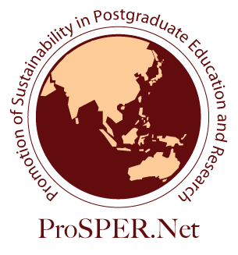

2022 ProSPER.Net Leadership Programme
“Shifting to Net Zero: Implementing strategies for net-zero transitions”

Organised by UNU-IAS (virtual)
5th - 8th, 16th December 2022 (5 days in total)

Application Form

- What are your motivations to apply for this programme? (Maximum 500 words)

- Describe your understanding of climate action and its importance towards sustainable development. (Maximum 500 words)

- Share your experiences in applying your knowledge of the concepts of net zero and sustainable development to address climate issues in your community, work or research. (Maximum 500 words)

- Demonstrate your experiences in project implementation or personal challenges where you had to exercise a leadership role. Provide examples. (Maximum 500 words)

- Provide a brief description of a project or activity related to sustainable development, net zero and climate change that you intend to implement or participate in the near future. (Maximum 500 words)

- List down your research publications and/or presentations (conferences, dissertation defence, etc).

I hereby certify that the information I have given on this application form is complete and correct to the best of my knowledge.

Full Name and Signature | Date

This form should be completed and submitted as an attachment, together with your CV and a recommendation letter from your direct supervisor/ manager through the online submission form by 11:59pm, Friday, 14 October 2022 (Japan Standard Time).
Please note that only selected applicants will be notified by the Secretariat.

