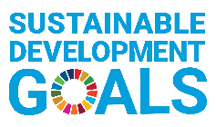
ESD Okayama Award 2022
－ Application Form －

Please ensure that the words do not exceed the limitation.
In the case word counts exceeds the limitation, demerit marks may be given.
(Please fill out the word counts in the column.)

- Information about your organization
(Please use extra space if needed.)
Name of Organization (For universities, please include the name of the department)
Name of Representative of Organization
Mailing Address  (including Postal Code) |  | Country
Telephone Number
Website, Facebook, etc.
Contact Person | [Name/ Title/ Department]
Email Address of Contact Person
Category of Organization | Please check one category that best describes your organization.
☐ School, University
☐ NGO, Civic Group
☐ Local Group, Community Learning Centre (CLC)
☐ Others (Please specify: )
Description of Organization | Please provide a summary description of your organization in a maximum of 150 words.
 | [Word counts: ( ) words]

- Information of your project

- Name
of Project
- Description  of Project | Please give an overview of your project including the objective and implementation method in a maximum of 150 words.
 | [Word counts: ( ) words]
 | Please write the URL of the project’s website if there is one.
- Basic Information | Duration | Started in (month/year) | ( / ) ※The project should be ongoing and have been running for at least two years as of April 2022. (The start day must be before March 2020.)
 |  | If the project is continued, circle “ongoing”, or if it is scheduled to be terminated in the future, please write the termination date (month/ year). | Ongoing / Termination Date ( / )
 | Target group(s) | Target area(s)
 |  | Target group(s)
 |  | Number of targeted people | about ( ) persons
 | Annual cost | Annual cost of the project | about ( ) US Dollars/ per year
 | Funding source(s) | Please explain the funding source(s) of the project, such as subsidies, donations, public funds, etc.
- Vision | Please describe the issues that local communities are facing in building a sustainable society, as well as objectives and goals of the project with numeral targets in Max. 150 words.
 | [Word counts: ( ) words]
- Collaboration | Please describe in detail the implementation system such as the structure of the collaborating groups and organizations and the rolls of each entity in words in Max 400 words. If you would like to use diagrams or images, all of them including the words should be within 2 pages or less. The resolution of such must be legible.
 | [Word counts: ( ) words]
- Integration | Please describe how the project integrates environmental, social, and economic dimensions of Sustainable Development, in Max. 200 words.
 | [Word counts: ( ) words]
- Innovation | Please describe how the project demonstrates innovative approaches and method to ESD in Max. 200 words.
 | [Word counts: ( ) words]
- Status of Implementation | Please describe objective evidence of activities such as feedback of project participants through questionnaires, numbers of participated individuals and groups, activity reports, brochures or publications, clips of news coverage, and past awards received in Max. 200 words.
 | [Word counts: ( ) words]

- Empowerment | - Please describe the kinds of educational approaches that the project is using in detail, such as interactive learning for problem-solving and/or participatory practices, in Max. 200 words.
 | [Word counts: ( ) words]
 | - Please describe achievements of the project and ways to disseminate the results in detail, such as how the project brought behavior change among the targeted groups including the transformation of values, attitudes and actions, and empowered local communities in Max. 200 Words.
 | [Word counts: ( ) words]
- Future Strategy | Please describe how you are planning to develop and expand the project in the future. Please also include detailed information such as any strategies, expected target groups, expected project duration and budgets per year, in max 150 words.
 | [Word counts: ( ) words]

- Contribution to the Sustainable Development Goals (SDGs)※
To which goal(s) of 17 Sustainable Development Goals does the project contribute?
※Please refer to the United Nations website about the SDGs. http://www.un.org/sustainabledevelopment/

- Please check all the goals to which the project contributes.
☐ 1 No Poverty  ☐ 2 Zero Hunger  ☐ 3 Good Health and Well-Being  ☐ 4 Quality Educationon  ☐ 5 Gender Equality  ☐ 6 Clean Water and Sanitation  ☐ 7 Affordable and Clean Energy  ☐ 8 Decent Work and Economic Growth  ☐ 9 Industry, Innovation and Infrastructure | ☐ 10 Reduced Inequalities  ☐ 11 Sustainable Cities and Communities  ☐ 12 Responsible Consumption and Production  ☐ 13 Climate Action  ☐ 14 Life below Water  ☐ 15 Life on Land  ☐ 16 Peace, Justice and strong Institutions  ☐ 17 Partnerships for the Goals
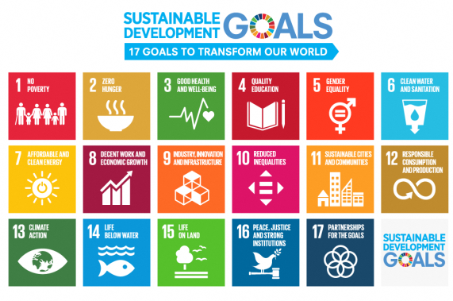
- Please select only ONE MAIN goal of the SDGs to which the project mainly contributes, and fill out the number.
- Please describe how the project contributes to the implementation of the one or several of the SDGs in Max. 200 words.
[Word counts: ( ) words]

- A Video or Slideshow of the project <Required>
Please prepare a video or slideshow of the project and upload it on YouTube or Facebook.
※Please note that a video or slideshow cannot be over 5 minutes.
※Please upload the data on YouTube or Facebook, and write the URL on the column of the Application Form. Please do NOT send the data by e-mail.
※If you have several videos or slideshows, please select ONE and give its URL.
※If you have any difficulty to make a video, please send us pictures of your activity by email (5 to 10 pictures).
URL of a video or a slideshow | Please provide the URL where the data was uploaded below.

- Other supporting documents <optional>
If you would like to submit any additional supporting documents, please list the titles of the documents below and submit them by email along with your application.
※Please note that documents CANNOT be more than 5 PAGES (A4 Paper) in total. Documents exceeding 5 pages will not be accepted or considered.
※Please note that the data must be less than 8MB. We cannot receive data exceeding 8MB.

1.
2.
3.

