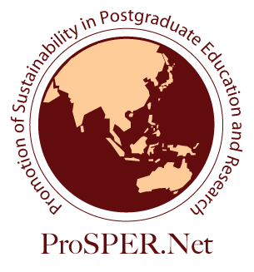

2021 ProSPER.Net Leadership Programme

“Climate Change: Global issues, local actions and transdisciplinary solutions”

Organised by UNU-IAS
In partnership with Social Innovation Japan
Virtual

14th -24th of September 2021

Application

Applications: Applications are open for professionals from academic, public, private, and civil society sectors working in the Asia-Pacific region, including affiliation to a ProSPER.Net member university and YRS Alumni.
Resource Persons: The programme will be delivered by leadership experts primarily from UNU-IAS and Social Innovation Japan.
Objectives:
Participants of the Leadership Programme will:
- To provide young professionals with an inclusive platform for dialogues and exchanges of diverse views and practical solutions on climate changes
- To guide and build solution-oriented thinking skills towards redesigning their practices vis-à-vis reflecting the diverse and complex local community needs
- To foster knowledge, skills and attitudes required for effective leadership and informed decision making in addressing climate crises at global and local levels

Selection Criteria: Participants will be selected on the basis of a written application, according to the following criteria:
- Professionals from academic, public, private, and civil society sectors working in the Asia-Pacific region, including affiliation to a ProSPER.Net member university and YRS Alumni, aged 35 or under as of the application deadline
- High proficiency in written and spoken English language
- An advanced understanding of sustainability and climate change and its relevance to his/her own work
- Demonstrated leadership ability to work in a team environment and contribute to climate actions

Participation fee: The participation fee is free.

2020 ProSPER.Net Leadership Programme
“Climate Change: Global issues, local actions and transdisciplinary solutions”
Organised by UNU-IAS
In partnership with Social Innovation Japan

Application Form
Family name
First and other names
Date of birth (Day/Month/Year) |  | Gender
Current location (City, Country) |  | Country of citizenship
Email
Present Occupation/Title/Affiliation/ Department/Organisation
Telephone/ Mobile telephone
- Have you participated in the LP? Yes / No
- Why are you interested in applying for this programme? Please describe your motivation. (maximum 500 words)

- Please describe your understanding of the sustainable development concept and your experiences in applying this concept to address climate change in your current work or student life (maximum 500 words)

- Demonstrate your ability to work in a team environment and/or share your experience in community development/service activities. (maximum 500 words)

- Please share your experiences in project implementation or personal challenges where you had to exercise a leadership role. (maximum 500 words)

- Provide a brief description of a project related to sustainable development and climate change that you plan to implement in the next year. (maximum 500 words)

- Research publications and/or presentations (conferences, dissertation defence, etc).

I hereby certify that the information I have given on this application form is complete and correct to the best of my knowledge.
Signature |  |  | Date
This form should be completed and emailed as an attachment, together with a CV and a recommendation letter from your direct supervisor/ manager to prospernet.lp@unu.edu by 11:59pm, Saturday 31 July 2021 (Japan Standard Time). *Please note that only selected applicants will be notified from the Secretariat. We regret we are not able to answer to inquiries regarding the selection process and the results.

